History of Euclidean Geometry History of Euclidean Geometry

Definition
# Source: AI Source: Provided by: [Data Path: Persons Table -> ID Column: 1, Name_En Column: Motasem Essam] -> From: [ChatGPT] on [7/25/2026]
The History of Euclidean Geometry is the study of how the principles, methods, concepts, and mathematical theories of Euclidean Geometry developed from ancient civilizations through classical Greek mathematics and into modern mathematics.
Euclidean Geometry is traditionally associated with Euclid of Alexandria, whose work Elements organized a large body of geometric knowledge into a systematic deductive framework.
However, Euclidean Geometry did not originate entirely with Euclid. Many geometric ideas had already been developed by earlier civilizations, particularly in Egypt and Mesopotamia, and by Greek mathematicians before Euclid.

Purpose
# Source: AI Source: Provided by: [Data Path: Persons Table -> ID Column: 1, Name_En Column: Motasem Essam] -> From: [ChatGPT] on [7/25/2026]
Studying the history of Euclidean Geometry helps us understand:
- How geometric ideas developed over time.
- How practical measurement evolved into mathematical theory.
- How Greek mathematicians introduced systematic geometric proofs.
- Why Euclid's Elements became so influential.
- How the axiomatic method developed.
- How the Parallel Postulate eventually led to non-Euclidean Geometry.
- How geometry became connected with algebra, analysis, topology, and modern mathematics.

1. Early Geometry Before the Greeks
# Source: AI Source: Provided by: [Data Path: Persons Table -> ID Column: 1, Name_En Column: Motasem Essam] -> From: [ChatGPT] on [7/25/2026]
Long before Euclid, ancient civilizations developed practical geometric techniques.
Geometry was initially closely connected with practical problems such as:
- Measuring land.
- Constructing buildings.
- Designing irrigation systems.
- Surveying.
- Architecture.
- Astronomy.
- Calculating areas and volumes.
Two particularly important civilizations were ancient Egypt and Mesopotamia.

2. Ancient Egyptian Geometry
# Source: AI Source: Provided by: [Data Path: Persons Table -> ID Column: 1, Name_En Column: Motasem Essam] -> From: [ChatGPT] on [7/25/2026]
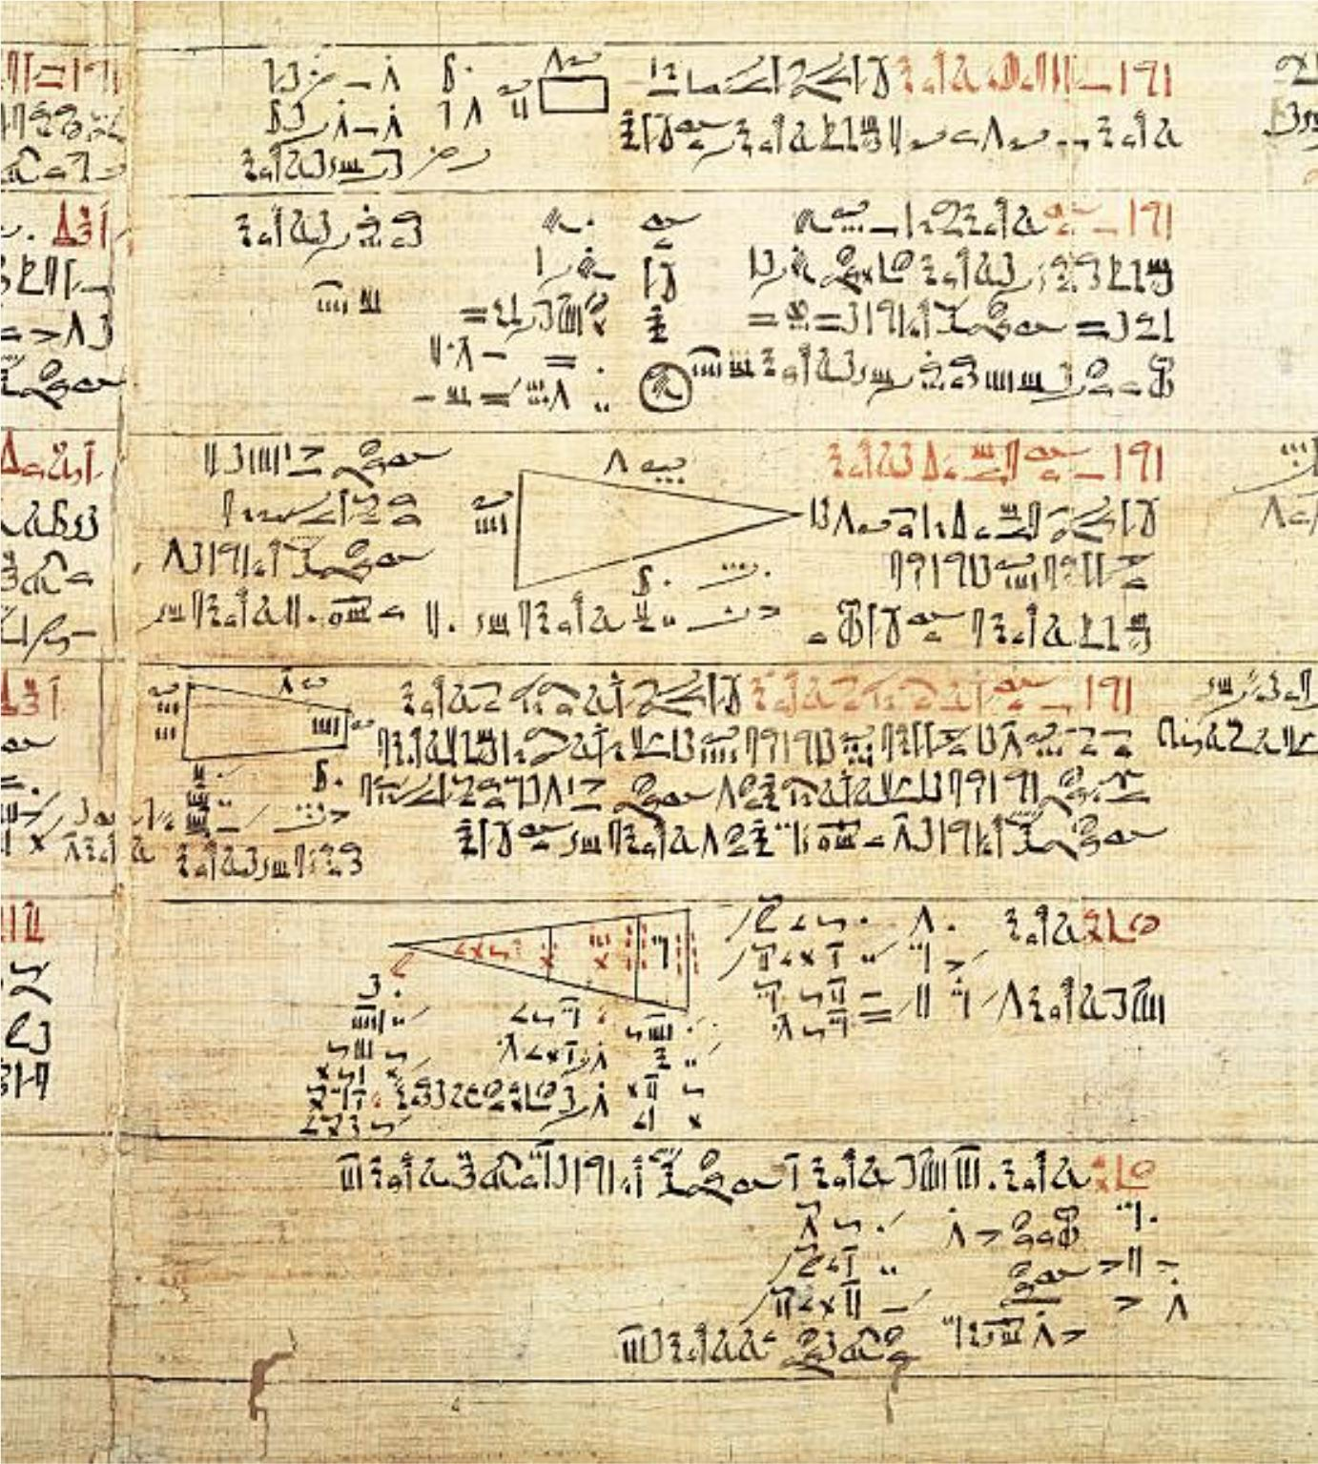
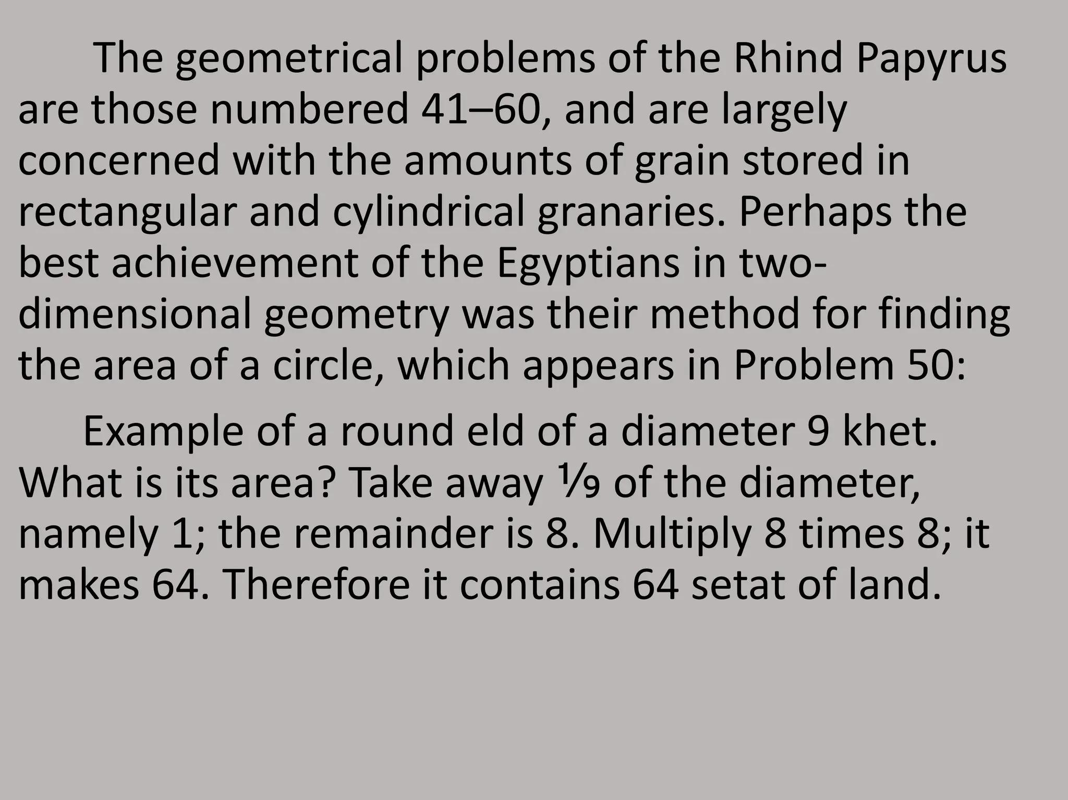
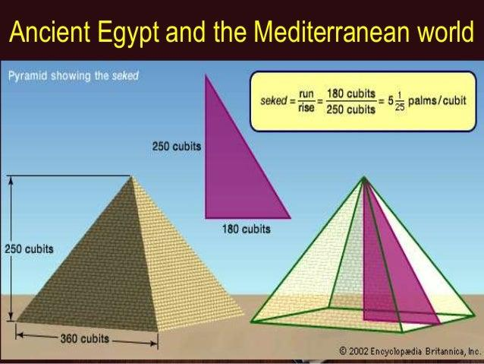
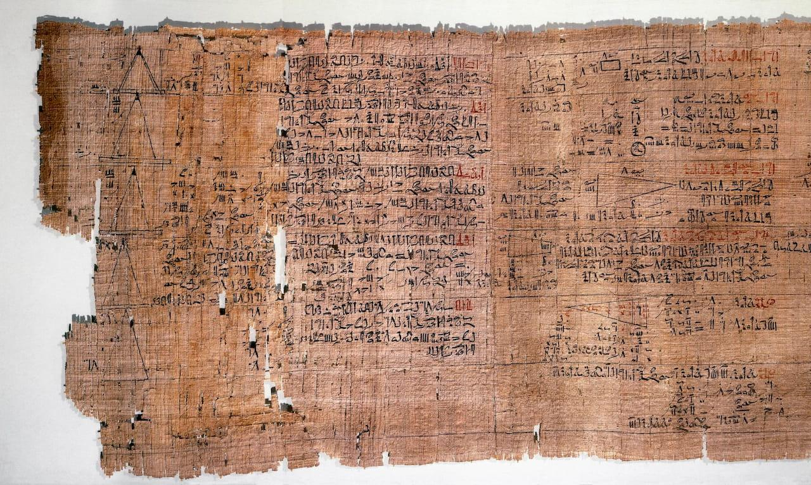
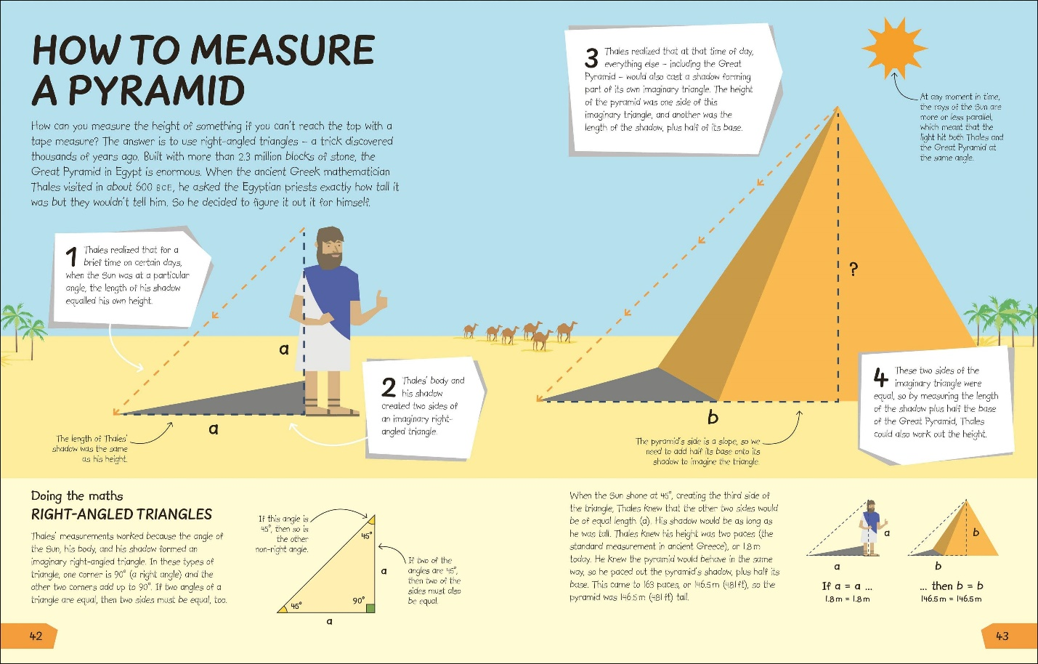
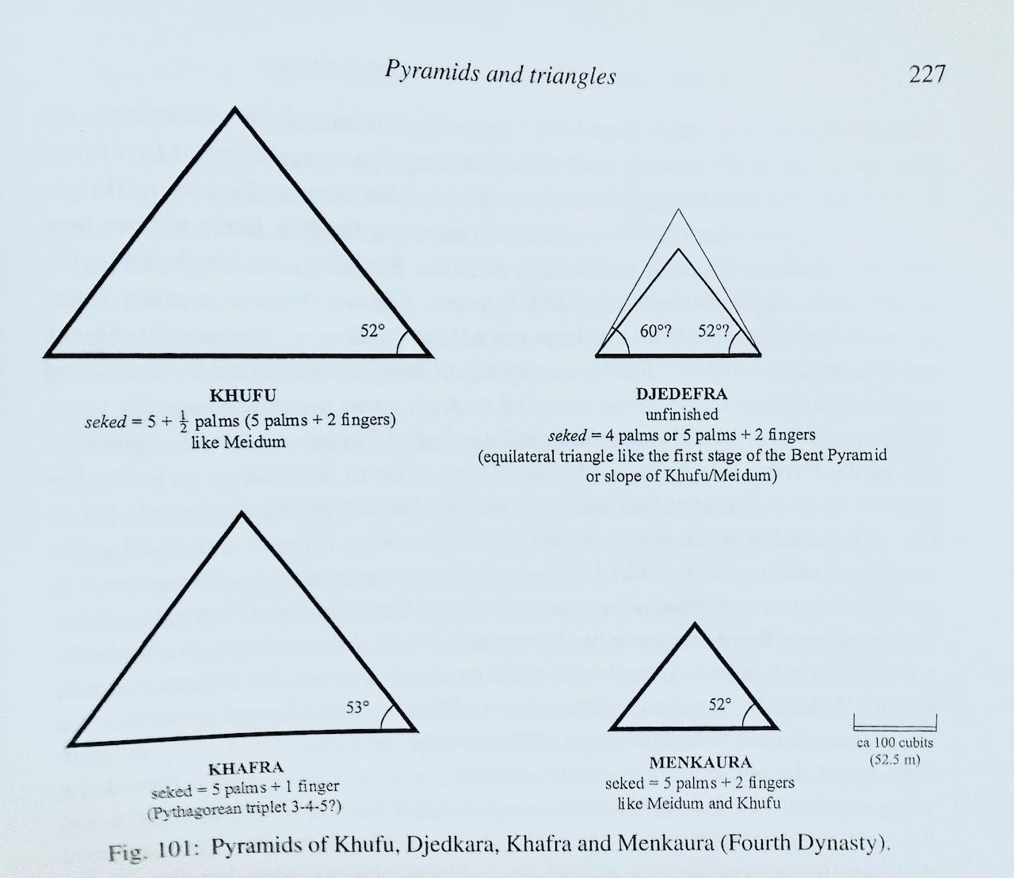
Ancient Egyptians developed practical methods for measuring and calculating geometric quantities.
One of the most important surviving mathematical documents is the Rhind Mathematical Papyrus, dating to around the second millennium BCE.
Egyptian mathematics included methods for:
- Calculating areas.
- Calculating volumes.
- Measuring fields.
- Working with fractions.
- Studying pyramids.
- Solving practical geometric problems.
For example, Egyptians used geometric procedures for calculating the area of a rectangle:
$$A=lw$$
and the area of a triangle:
$$A=\frac{1}{2}bh$$
These methods were primarily practical computational techniques, rather than the fully axiomatic proof system that later characterized Greek geometry.

3. Mesopotamian Geometry
# Source: AI Source: Provided by: [Data Path: Persons Table -> ID Column: 1, Name_En Column: Motasem Essam] -> From: [ChatGPT] on [7/25/2026]
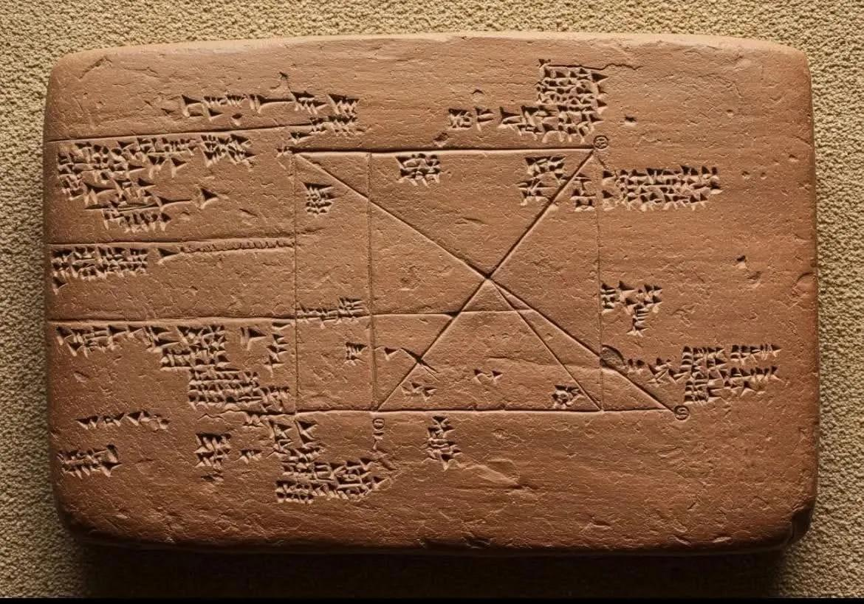
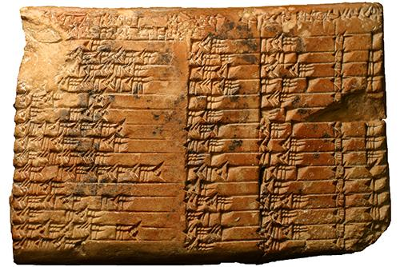
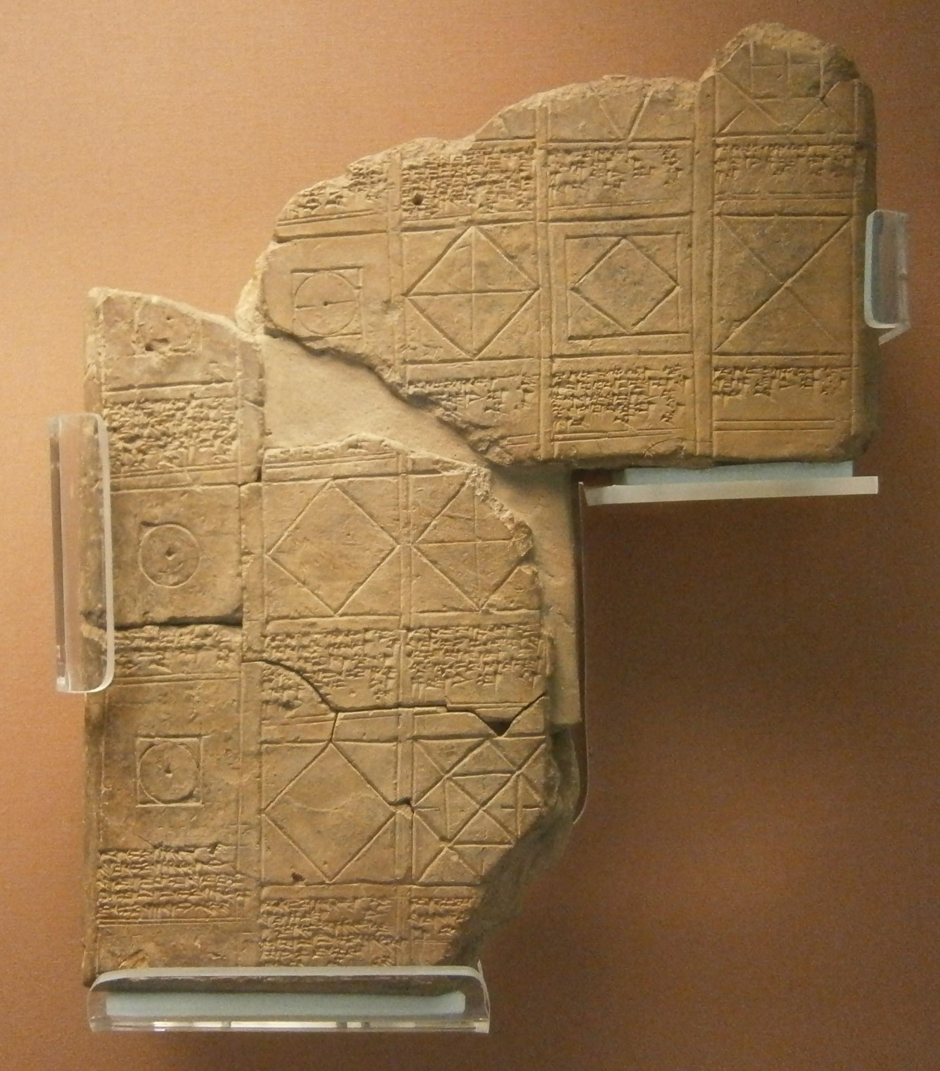
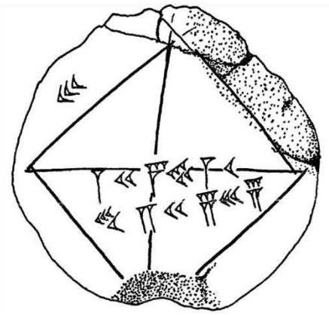
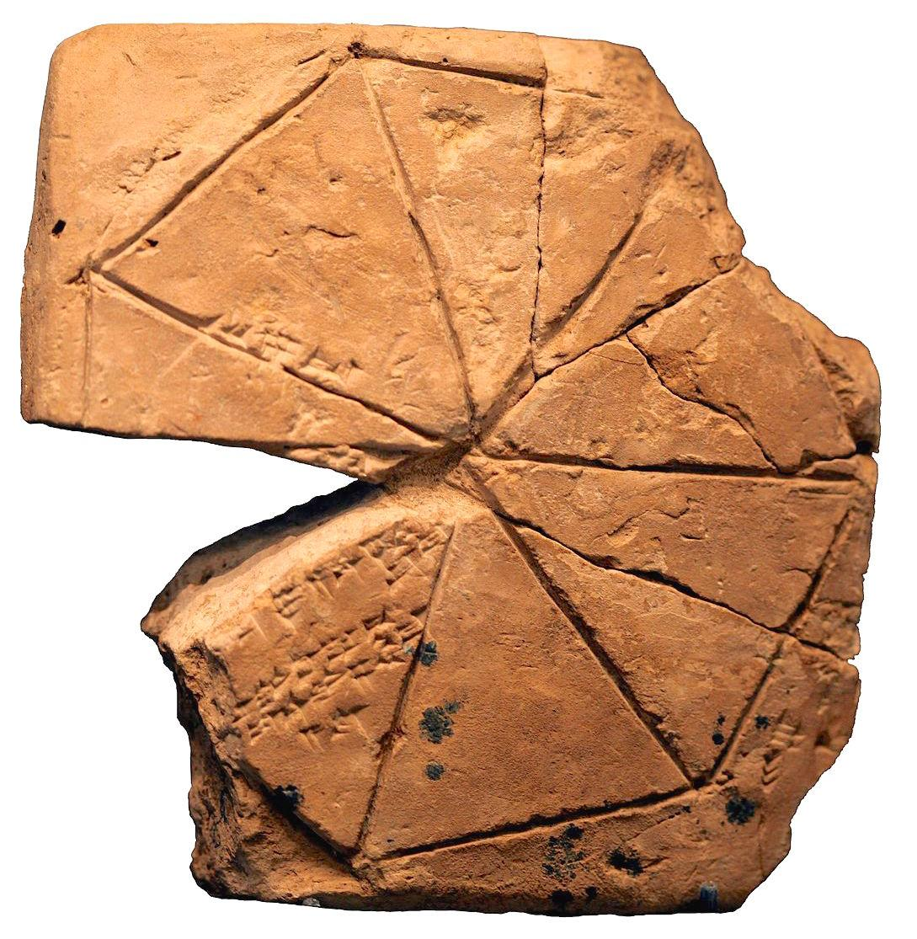
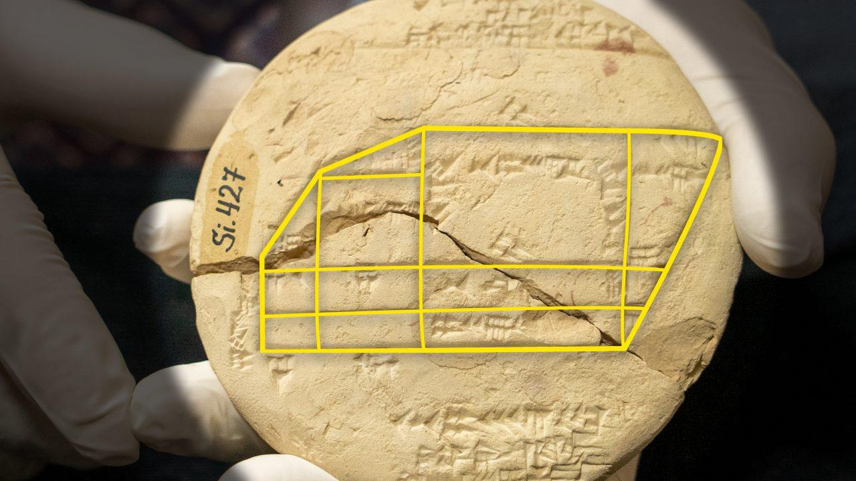
Mathematicians in ancient Mesopotamia also developed sophisticated mathematical methods.
Babylonian mathematical tablets demonstrate knowledge of:
- Areas.
- Volumes.
- Right triangles.
- Ratios.
- Quadratic equations.
- Numerical approximations.
- Practical surveying calculations.
Some Babylonian calculations are closely related to what we now recognize as Pythagorean triples.
For example:
$$3^{2}+4^{2}=5^{2} \\ 9+16=25$$
However, these ancient computational methods generally did not use the deductive axiomatic structure later associated with Euclid.

4. Greek Geometry
# Source: AI Source: Provided by: [Data Path: Persons Table -> ID Column: 1, Name_En Column: Motasem Essam] -> From: [ChatGPT] on [7/25/2026]
Around the first millennium BCE, Greek mathematicians transformed geometry from primarily practical calculation into a more abstract and deductive mathematical discipline.
Instead of asking only:
"How can we calculate this length?"
Greek mathematicians increasingly asked:
"Why is this relationship necessarily true?"
This shift was extremely important.
Geometry became based on:
$$\boxed{\text{Definitions}+\text{Axioms}+\text{Postulates}+\text{Logical Proof}}$$

5. Thales of Miletus
# Source: AI Source: Provided by: [Data Path: Persons Table -> ID Column: 1, Name_En Column: Motasem Essam] -> From: [ChatGPT] on [7/25/2026]
Thales of Miletus, traditionally dated to around the 6th century BCE, is often regarded as one of the earliest Greek mathematicians associated with deductive geometry.
He is traditionally credited with results involving:
- Angles.
- Similarity.
- Triangles.
- Circles.
- Proportionality.
A famous result associated with Thales is the theorem that an angle subtended by a diameter of a circle is a right angle:
$$\boxed{{90}^{∘}}$$
The historical details surrounding Thales are uncertain, and later Greek sources may have attributed results to him that were developed more fully by later mathematicians.

6. Pythagoras and the Pythagorean Tradition
# Source: AI Source: Provided by: [Data Path: Persons Table -> ID Column: 1, Name_En Column: Motasem Essam] -> From: [ChatGPT] on [7/25/2026]
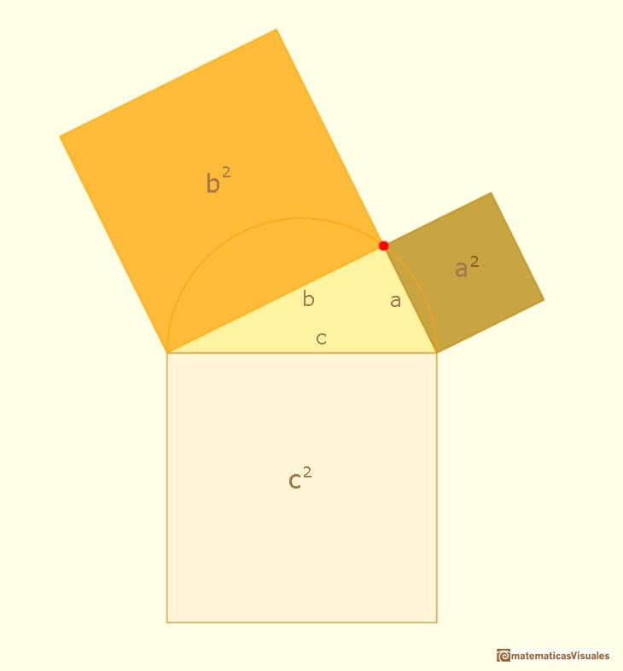
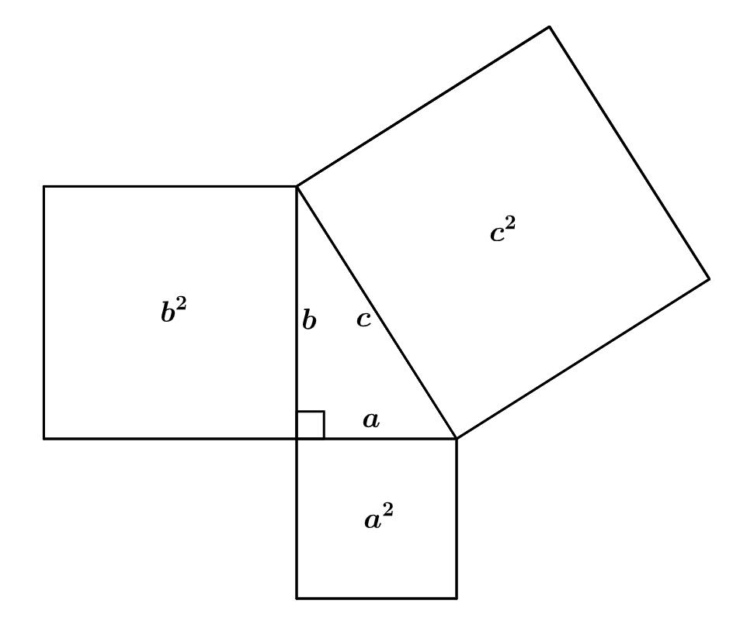
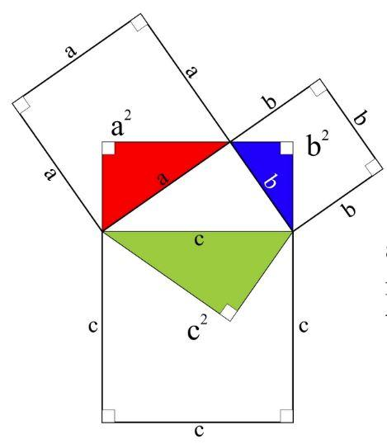
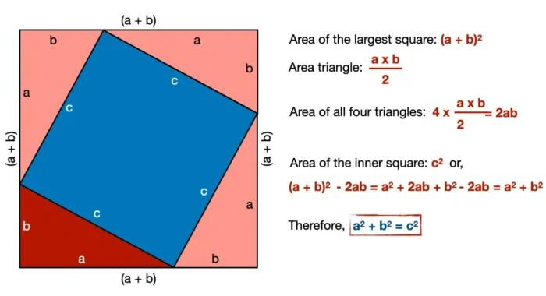
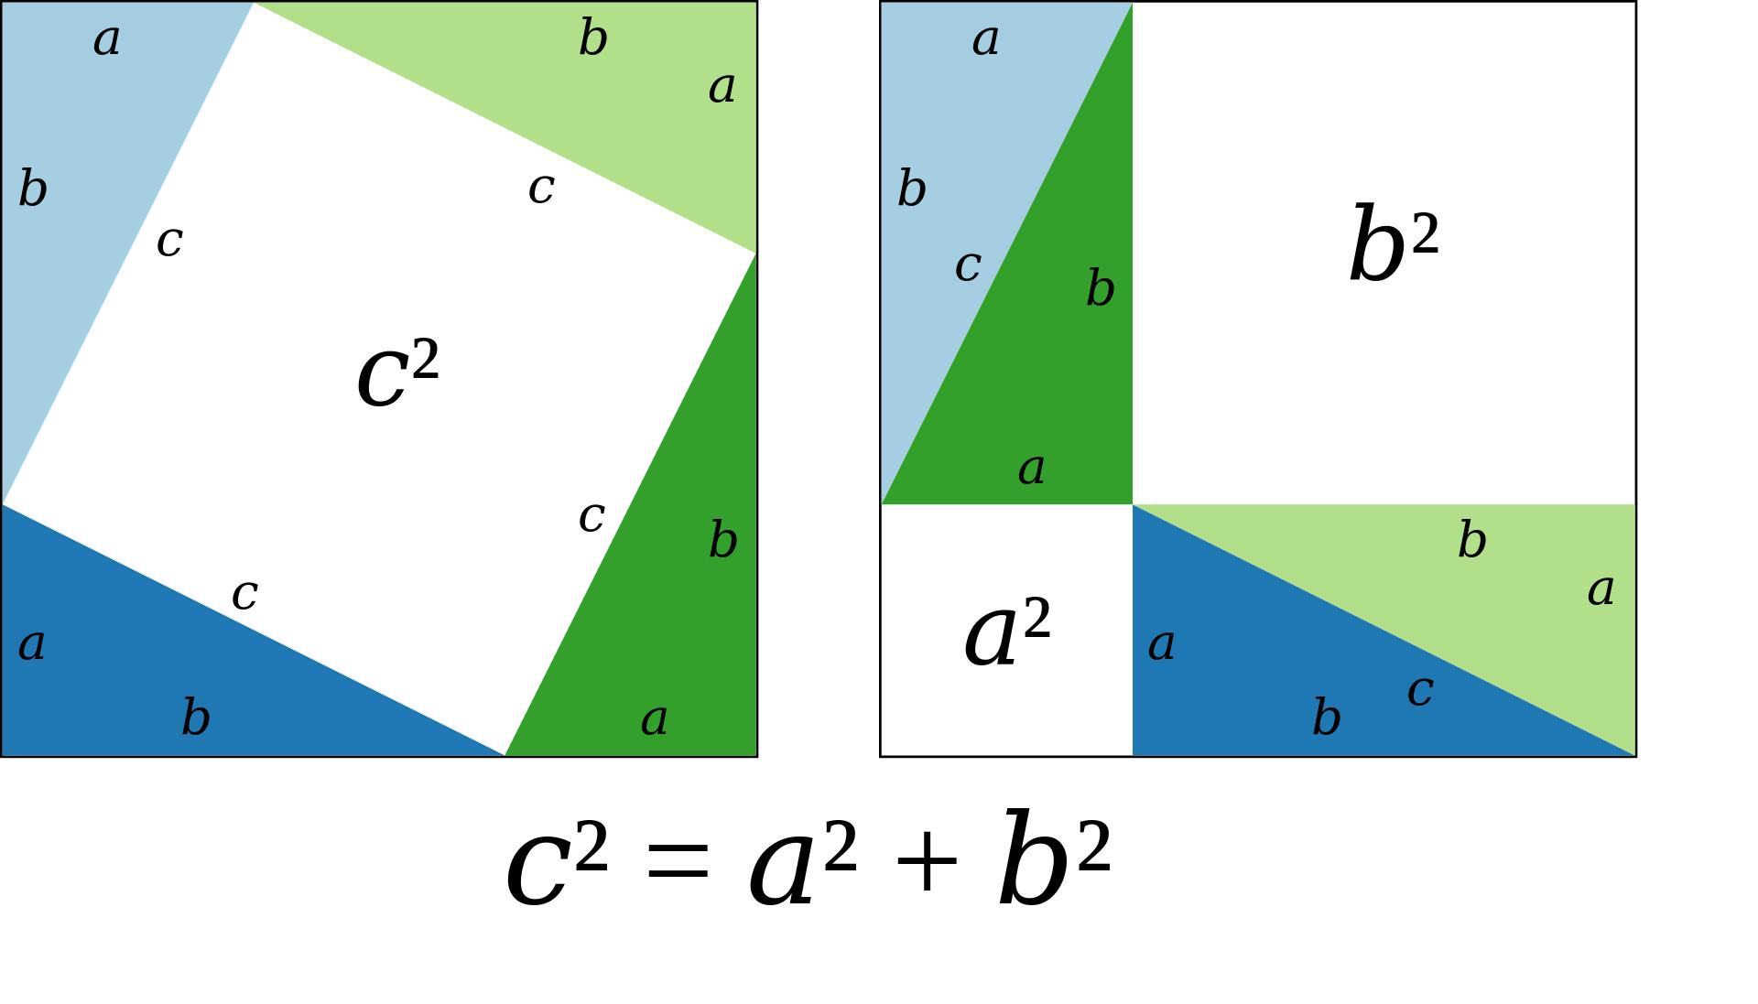
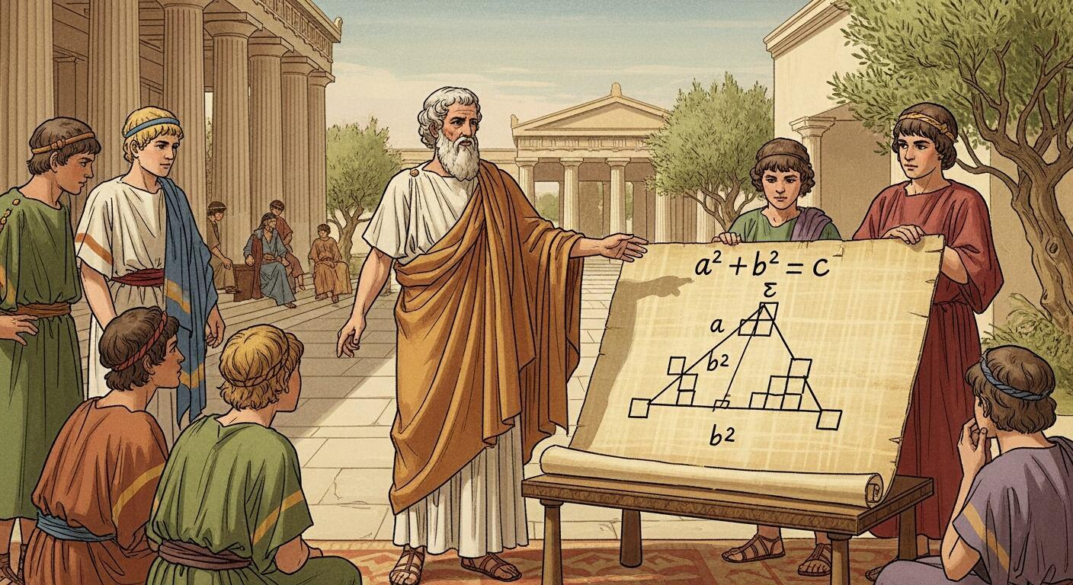
Pythagoras and the Pythagorean tradition played an important role in the development of mathematical thought.
The famous Pythagorean Theorem states that for a right triangle:
$$\boxed{a^{2}+b^{2}=c^{2}}$$
where $c$is the hypotenuse.
The theorem was known in some form before Pythagoras, including in ancient Babylonian mathematics, but the Greek mathematical tradition helped establish it as part of a deductive geometric framework.

7. Plato and the Importance of Mathematics
# Source: AI Source: Provided by: [Data Path: Persons Table -> ID Column: 1, Name_En Column: Motasem Essam] -> From: [ChatGPT] on [7/25/2026]
Plato and his philosophical school contributed to the intellectual environment in which Greek mathematics developed.
Geometry became associated with:
- Abstract reasoning.
- Logical demonstration.
- Ideal mathematical objects.
- Mathematical education.
This helped strengthen the idea that mathematics should investigate general truths, rather than merely provide practical calculation procedures.

8. Eudoxus of Cnidus
# Source: AI Source: Provided by: [Data Path: Persons Table -> ID Column: 1, Name_En Column: Motasem Essam] -> From: [ChatGPT] on [7/25/2026]
Eudoxus made important contributions to Greek mathematics.
His work included:
- Proportionality.
- Geometry.
- The theory of magnitudes.
- The method of exhaustion.
The method of exhaustion was an important precursor to ideas later associated with integration.
It allowed mathematicians to approximate areas and volumes using increasingly fine subdivisions.

9. Euclid of Alexandria
# Source: AI Source: Provided by: [Data Path: Persons Table -> ID Column: 1, Name_En Column: Motasem Essam] -> From: [ChatGPT] on [7/25/2026]
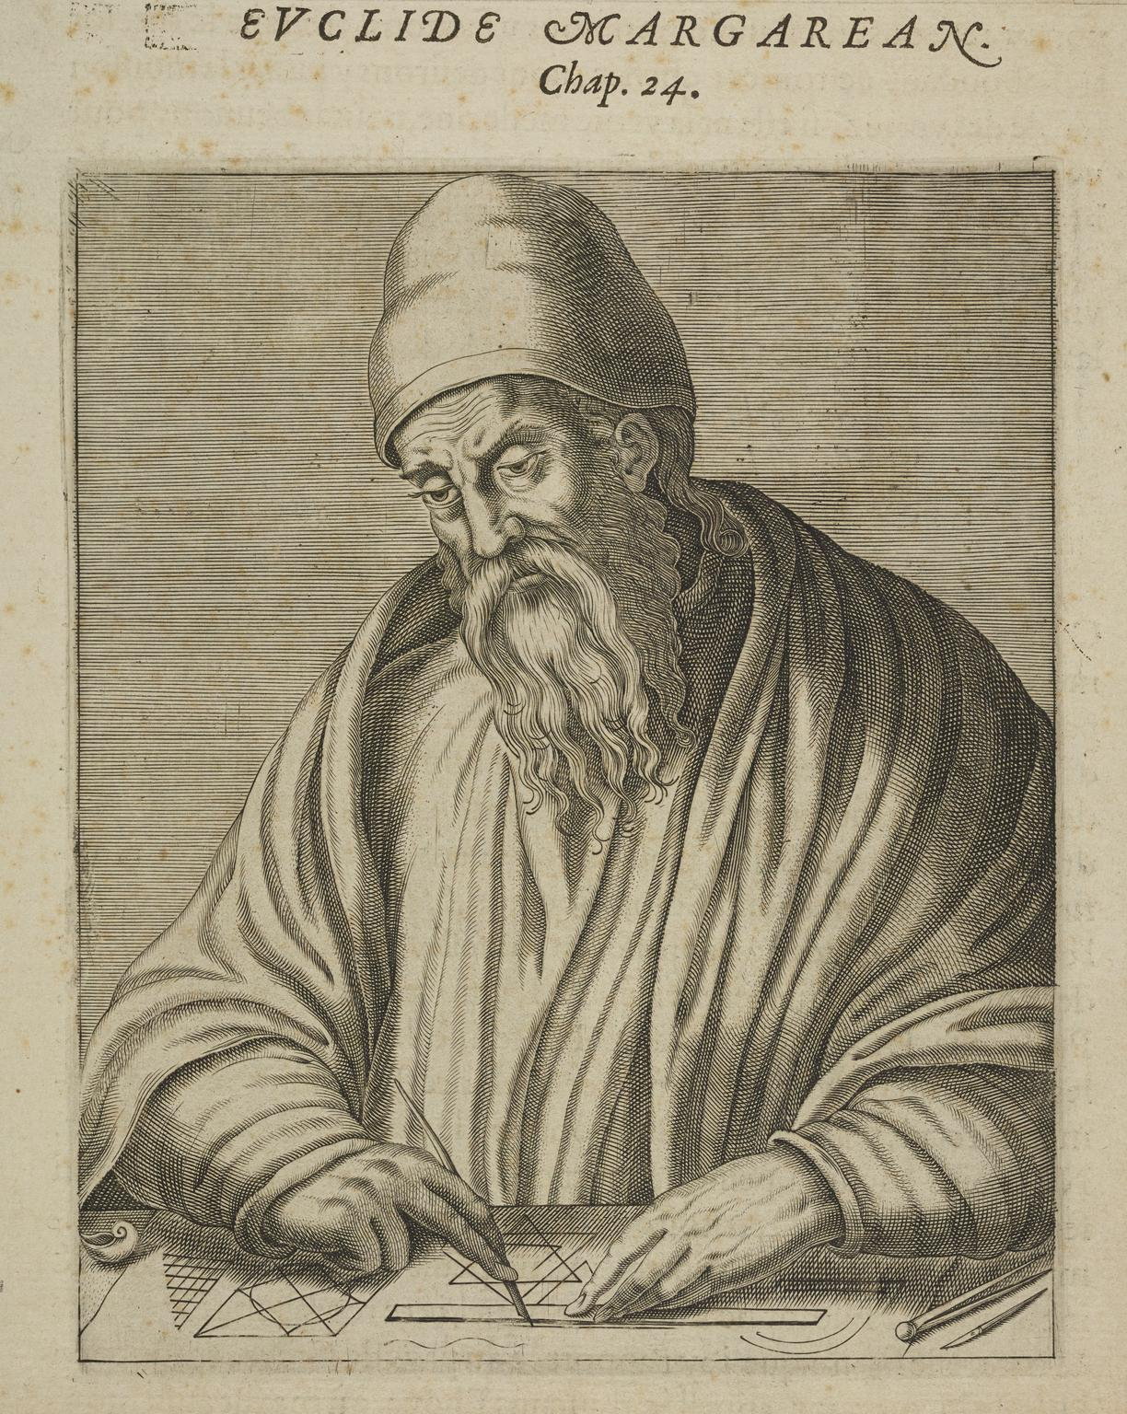
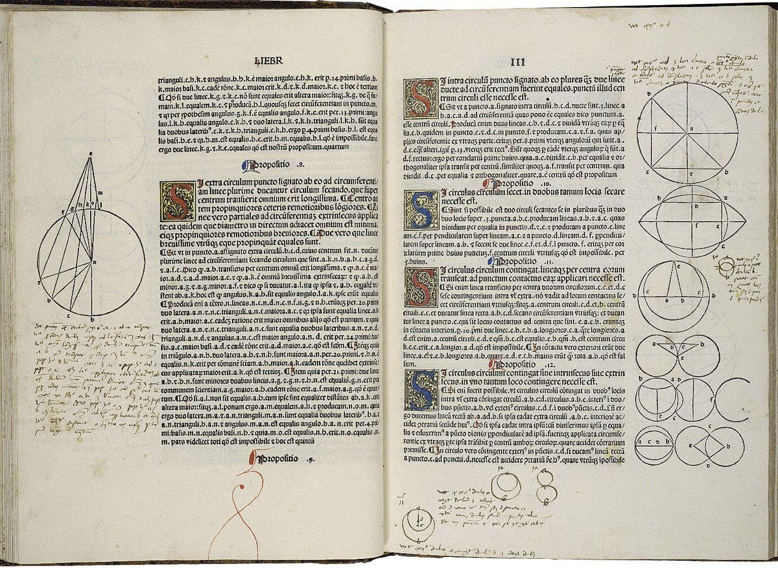
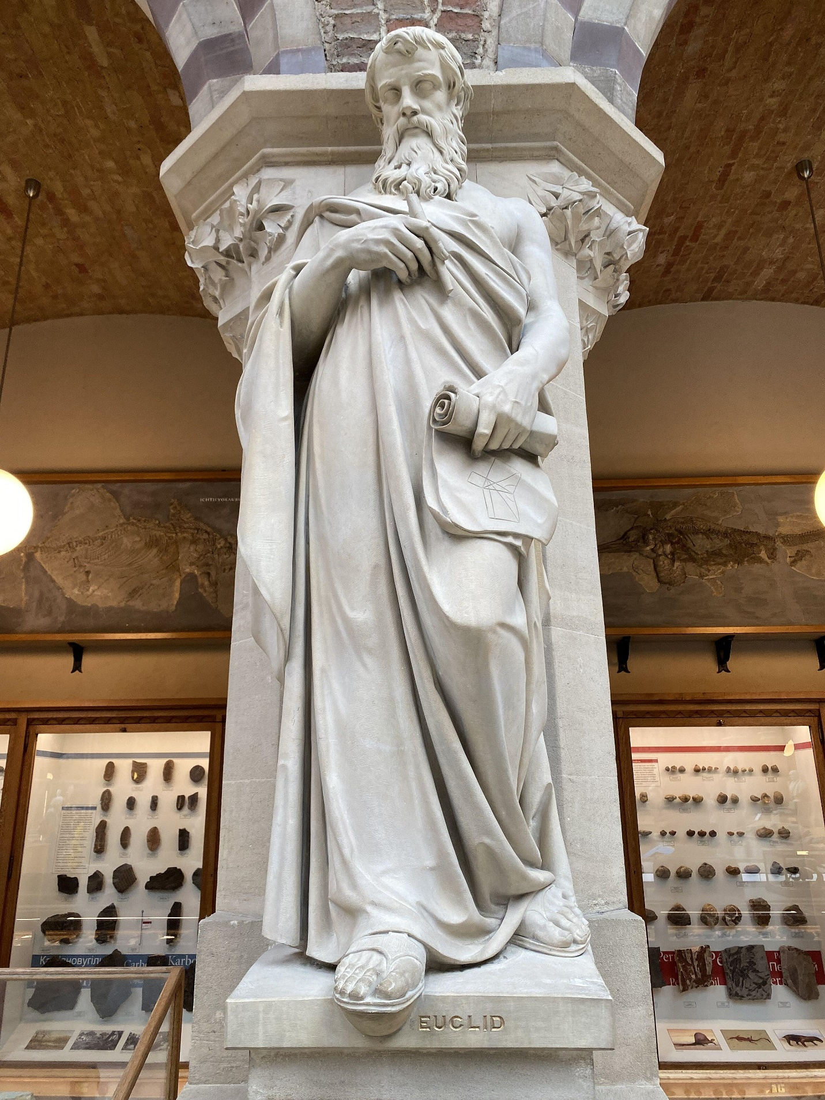
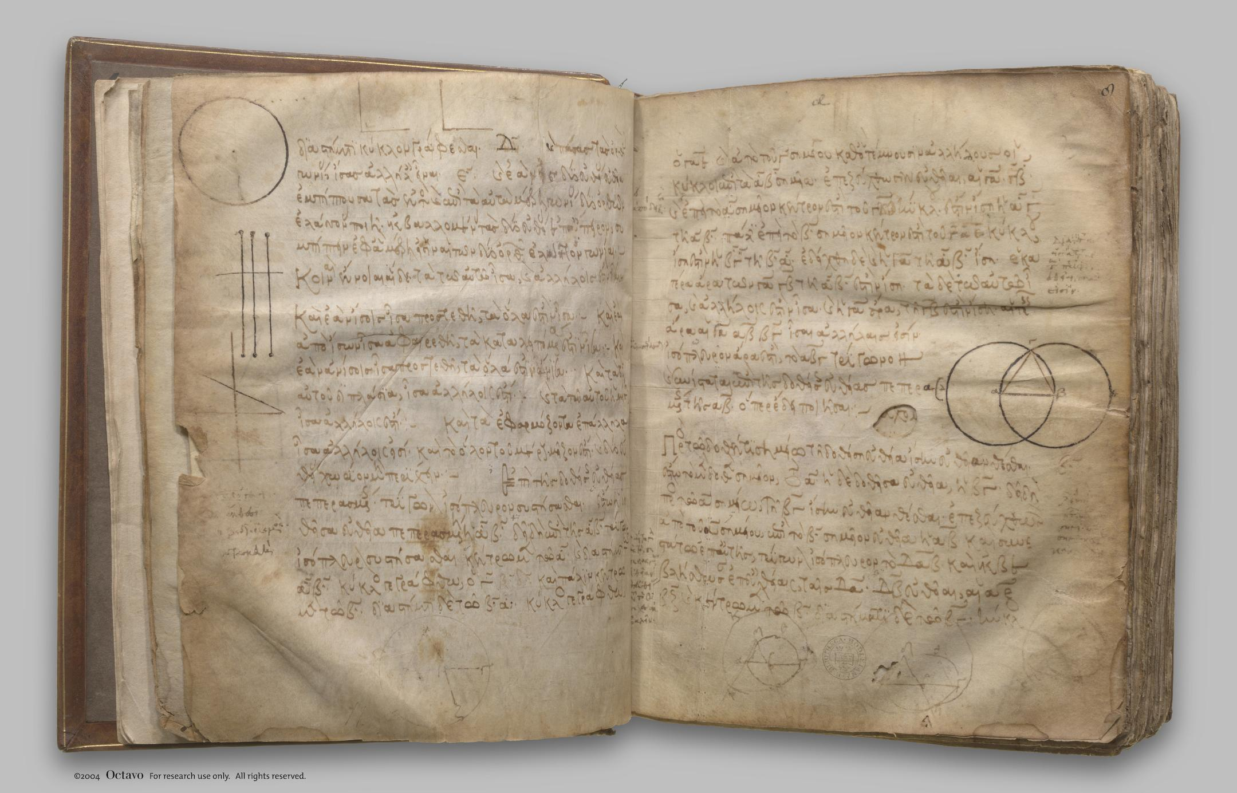
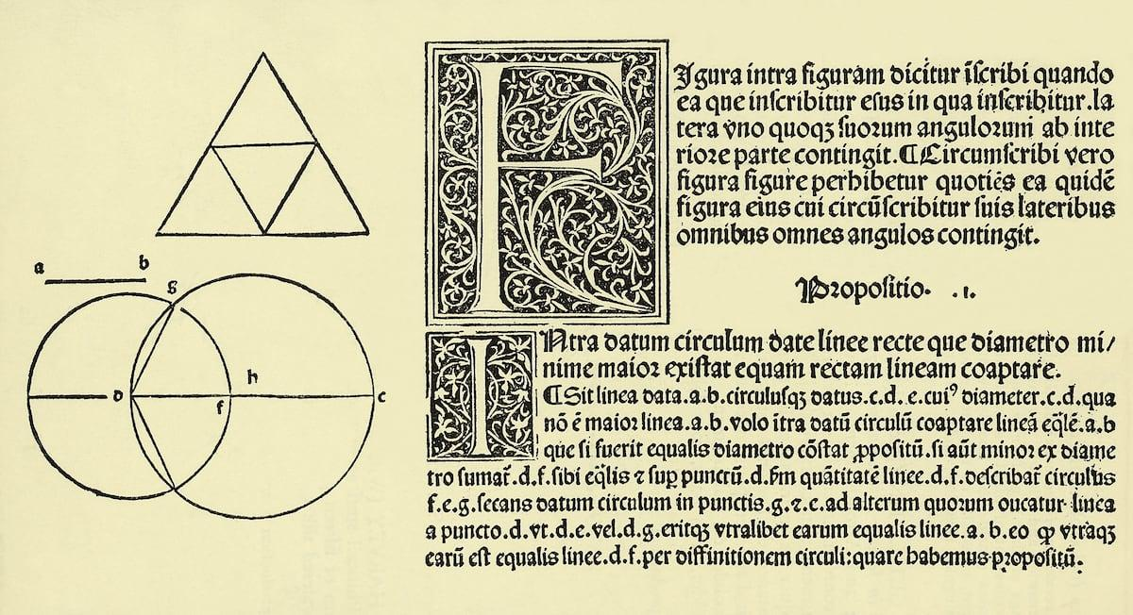
Euclid of Alexandria, probably active around 300 BCE, became the central historical figure associated with classical Euclidean Geometry.
Very little is known with certainty about Euclid's personal life.
His greatest surviving work is:
$$\boxed{\text{The Elements}}$$

10. Euclid's Elements
# Source: AI Source: Provided by: [Data Path: Persons Table -> ID Column: 1, Name_En Column: Motasem Essam] -> From: [ChatGPT] on [7/25/2026]
The Elements is one of the most influential mathematical works in history.
It consists of 13 books covering topics including:
- Plane geometry.
- Number theory.
- Proportions.
- Geometric constructions.
- Solid geometry.
- Regular polyhedra.
Euclid did not simply collect isolated geometric formulas. He organized mathematical statements into a deductive system.
The basic structure was approximately:
$$\text{Definitions} \\ ↓ \\ \text{Postulates and Common Notions} \\ ↓ \\ \text{Propositions} \\ ↓ \\ \text{Proofs} \\ ↓ \\ \text{Further Propositions}$$
This systematic organization is one of the main reasons The Elements became so influential.

11. Euclid's Five Postulates
# Source: AI Source: Provided by: [Data Path: Persons Table -> ID Column: 1, Name_En Column: Motasem Essam] -> From: [ChatGPT] on [7/25/2026]
Euclid established five famous geometric postulates.
Postulate 1
A straight line can be drawn from any point to any point.
Postulate 2
A finite straight line can be extended indefinitely in a straight line.
Postulate 3
A circle can be drawn with any center and radius.
Postulate 4
All right angles are equal.
Postulate 5
The famous Parallel Postulate concerns the conditions under which two lines meet.
A modern equivalent is the Playfair formulation:
Through a point not on a given line, exactly one line can be drawn parallel to the given line.
The fifth postulate would eventually become one of the most important topics in the history of geometry.

12. Euclid's Geometric Method
# Source: AI Source: Provided by: [Data Path: Persons Table -> ID Column: 1, Name_En Column: Motasem Essam] -> From: [ChatGPT] on [7/25/2026]
Euclid's method established a powerful mathematical model:
$$\boxed{\text{Start with basic assumptions and prove increasingly complex results}}$$
For example:
Definitions
↓
Axioms / Common Notions
↓
Postulates
↓
Propositions
↓
Proofs
↓
Theorems
↓
Further Results
This approach became an important model for mathematical reasoning far beyond geometry.

13. Hellenistic Development After Euclid
# Source: AI Source: Provided by: [Data Path: Persons Table -> ID Column: 1, Name_En Column: Motasem Essam] -> From: [ChatGPT] on [7/25/2026]
Euclidean Geometry continued to develop after Euclid.
Important mathematicians included:
Archimedes
Archimedes made major contributions to:
- Geometry.
- Areas.
- Volumes.
- Circles.
- Spheres.
- Cylinders.
- The method of exhaustion.
For a circle:
$$A=πr^{2}$$
and:
$$C=2πr$$
Archimedes obtained increasingly accurate approximations to $π$.
Apollonius of Perga
Apollonius made major contributions to the study of conic sections:
- Ellipse.
- Parabola.
- Hyperbola.
These became extremely important later in astronomy, physics, and analytic geometry.

14. Preservation and Transmission
# Source: AI Source: Provided by: [Data Path: Persons Table -> ID Column: 1, Name_En Column: Motasem Essam] -> From: [ChatGPT] on [7/25/2026]
After the classical Greek period, Greek mathematical works were copied, studied, translated, and transmitted through different intellectual traditions.
A major role was played by scholars working in the Islamic Golden Age.
Greek mathematical texts, including The Elements, were translated into Arabic and studied extensively.
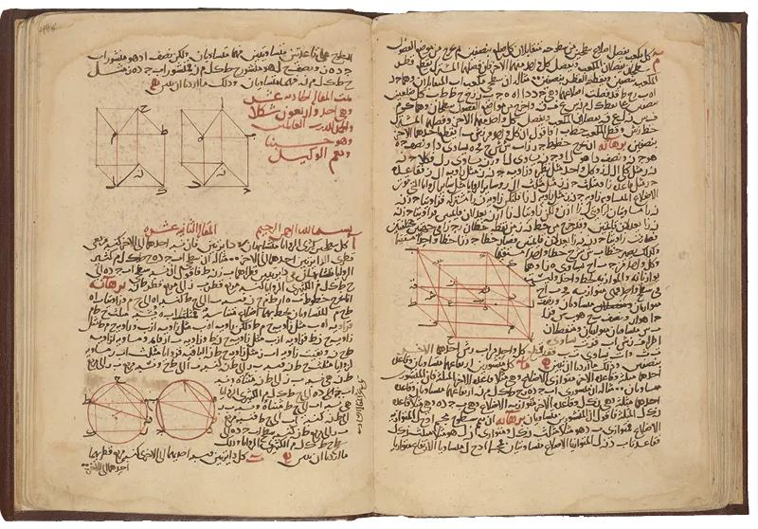
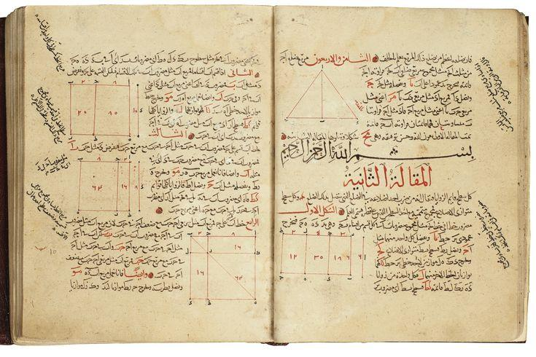
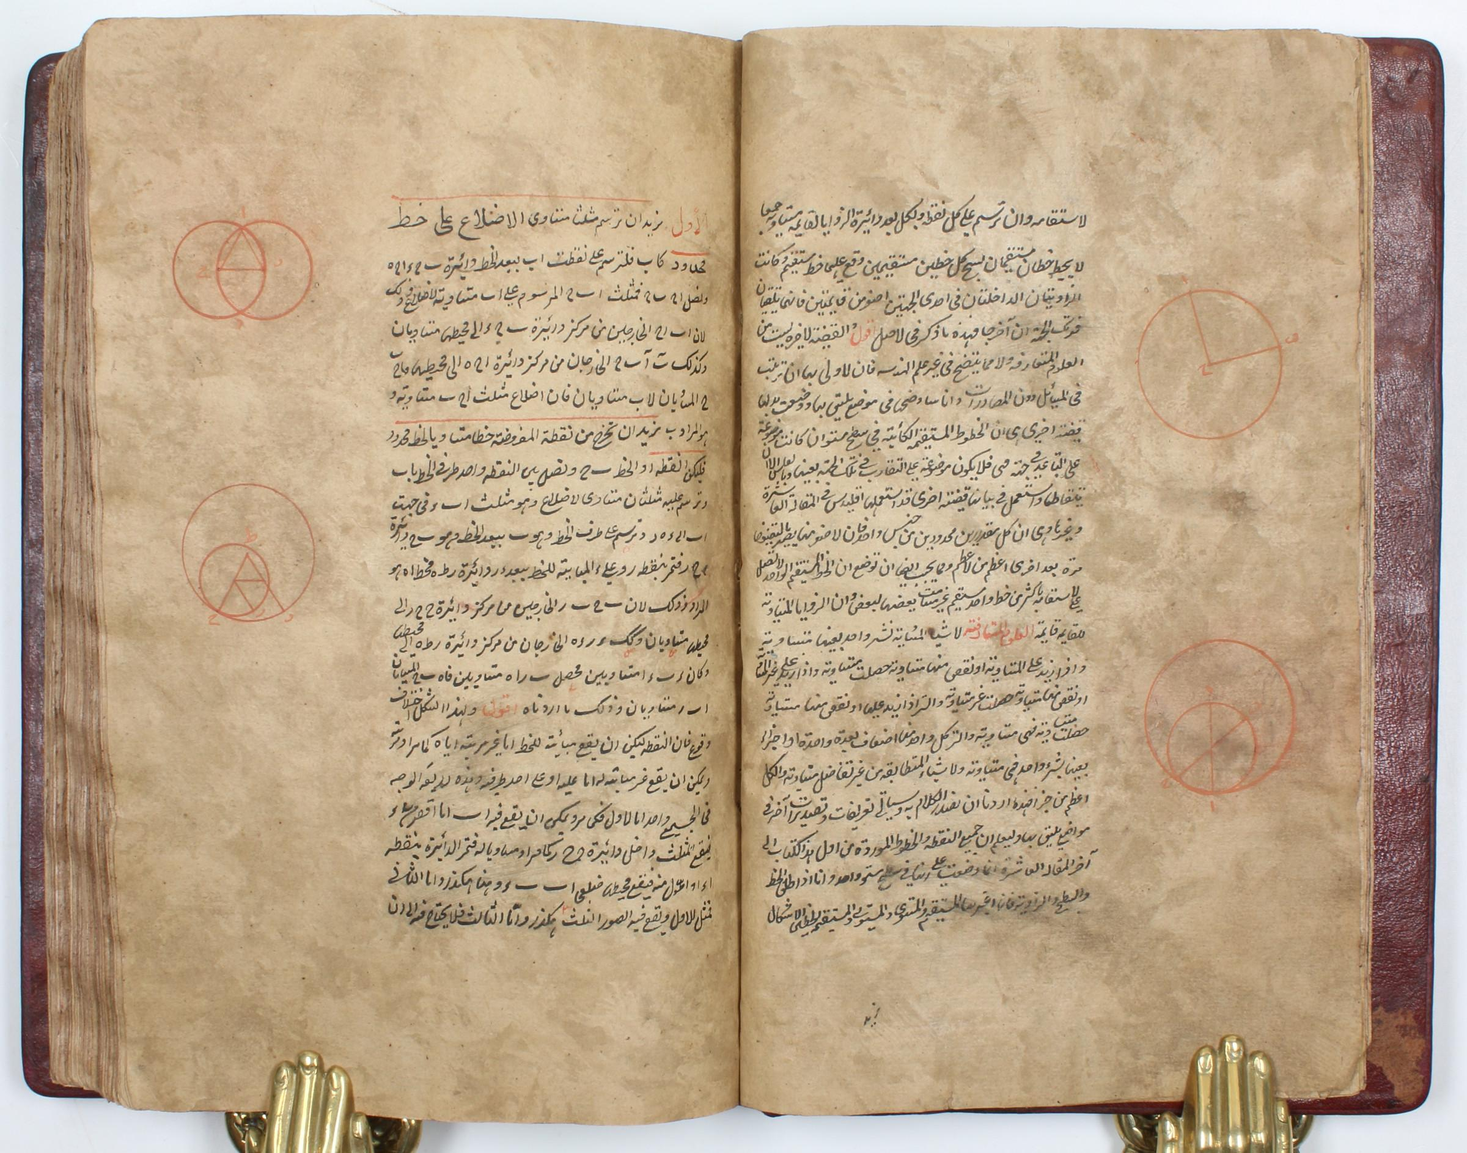
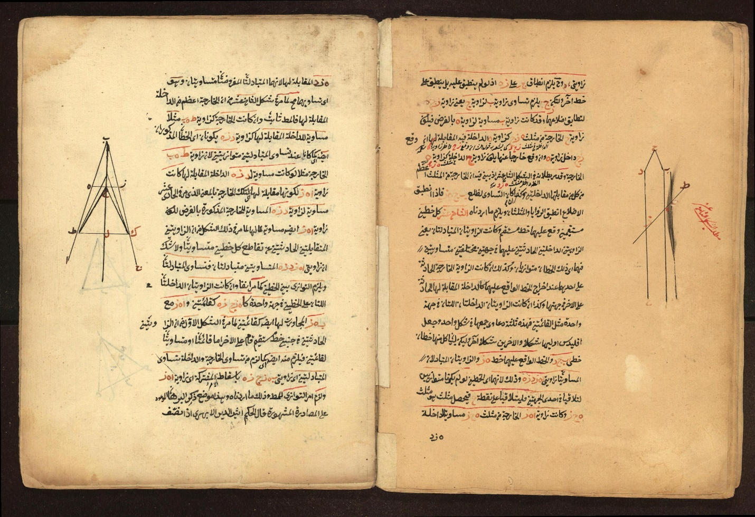
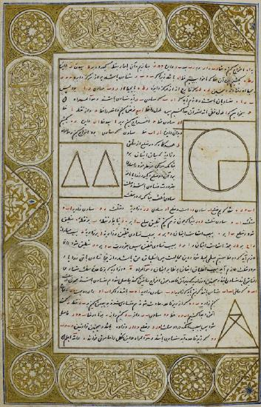
This transmission was extremely important for preserving and developing Greek mathematical knowledge.

15. Islamic Golden Age
# Source: AI Source: Provided by: [Data Path: Persons Table -> ID Column: 1, Name_En Column: Motasem Essam] -> From: [ChatGPT] on [7/25/2026]
From approximately the 8th to the 14th centuries, scholars working in the Islamic world made significant contributions to mathematics and astronomy.
They:
- Translated Greek mathematical works.
- Preserved earlier mathematical texts.
- Developed mathematical methods.
- Studied Euclidean Geometry.
- Expanded geometric constructions.
- Connected geometry with algebra and astronomy.
Important mathematicians included:
- Al-Khwarizmi
- Thabit ibn Qurra
- Ibn al-Haytham
- Omar Khayyam
- Nasir al-Din al-Tusi
Their work helped transmit Greek mathematics to later European scholars.

16. Thabit ibn Qurra
# Source: AI Source: Provided by: [Data Path: Persons Table -> ID Column: 1, Name_En Column: Motasem Essam] -> From: [ChatGPT] on [7/25/2026]
Thabit ibn Qurra made important contributions to:
- Geometry.
- Number theory.
- Astronomy.
- Translation of Greek mathematical works.
He was particularly important in transmitting and extending Greek mathematical knowledge in Arabic.

17. Ibn al-Haytham
# Source: AI Source: Provided by: [Data Path: Persons Table -> ID Column: 1, Name_En Column: Motasem Essam] -> From: [ChatGPT] on [7/25/2026]
Ibn al-Haytham made significant contributions to mathematical science, optics, and geometry.
His mathematical work included geometric problems and constructions.
His work demonstrates how Euclidean geometric methods continued to develop in the medieval Islamic mathematical tradition.

18. Renaissance Europe
# Source: AI Source: Provided by: [Data Path: Persons Table -> ID Column: 1, Name_En Column: Motasem Essam] -> From: [ChatGPT] on [7/25/2026]
During the European Renaissance, Greek mathematical works became increasingly available to European scholars through manuscripts, translations, and printed editions.
The invention of the printing press greatly increased the ability to reproduce mathematical texts.
Euclid's Elements became an important mathematical textbook throughout Europe.
Geometry became increasingly important in:
- Architecture.
- Art.
- Perspective.
- Engineering.
- Astronomy.
- Navigation.

19. Descartes and Analytic Geometry
# Source: AI Source: Provided by: [Data Path: Persons Table -> ID Column: 1, Name_En Column: Motasem Essam] -> From: [ChatGPT] on [7/25/2026]
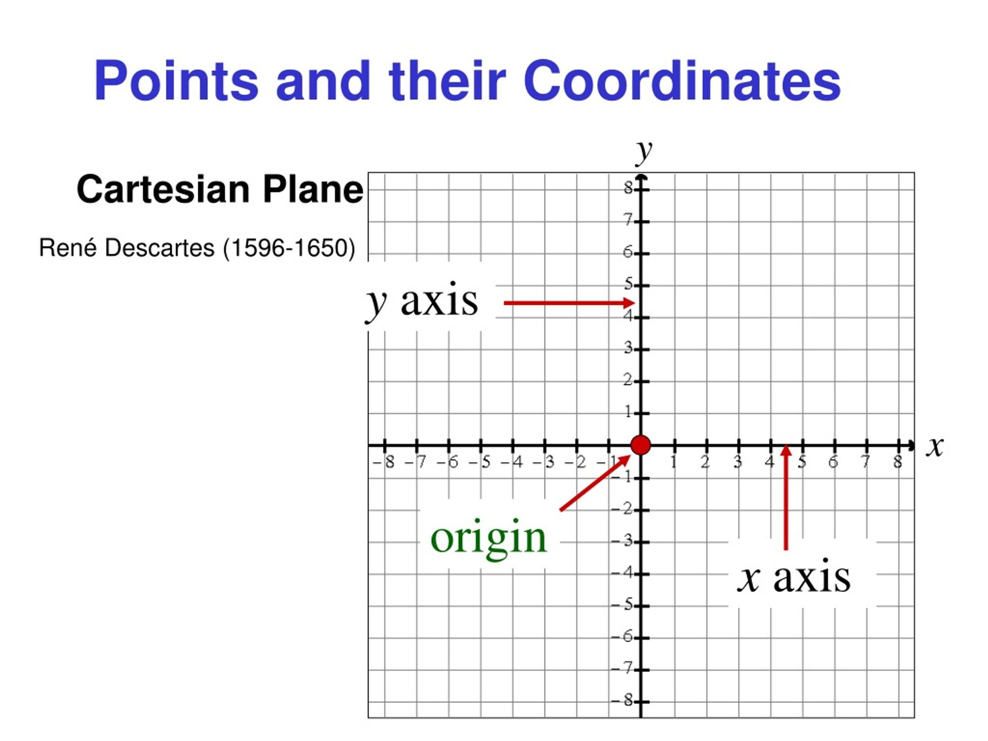
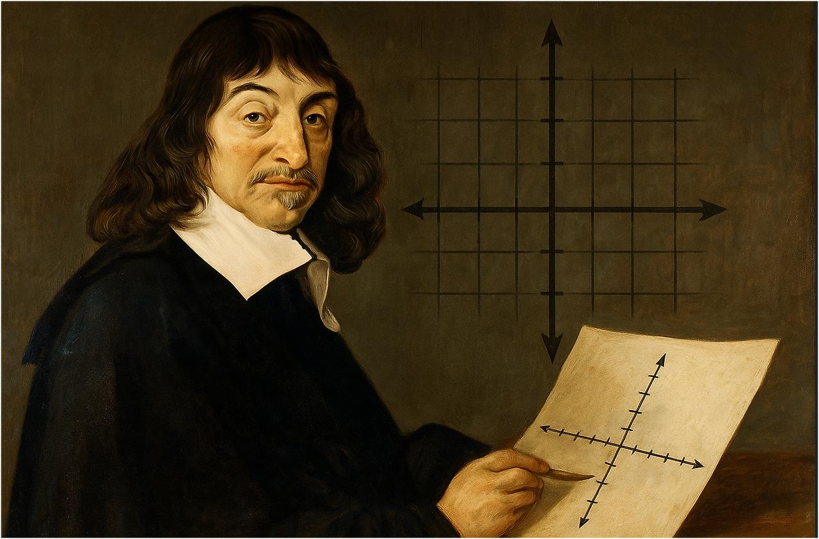
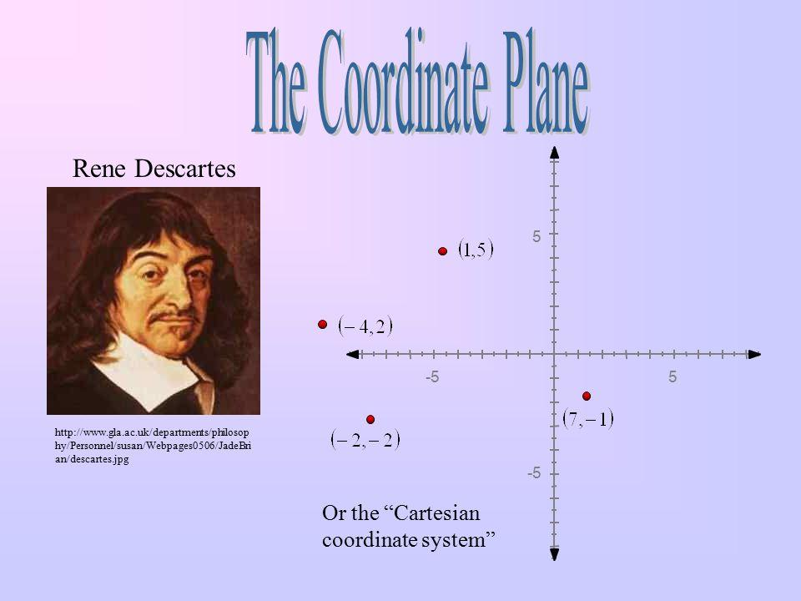
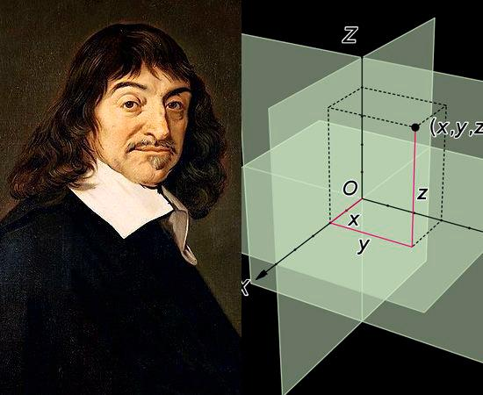
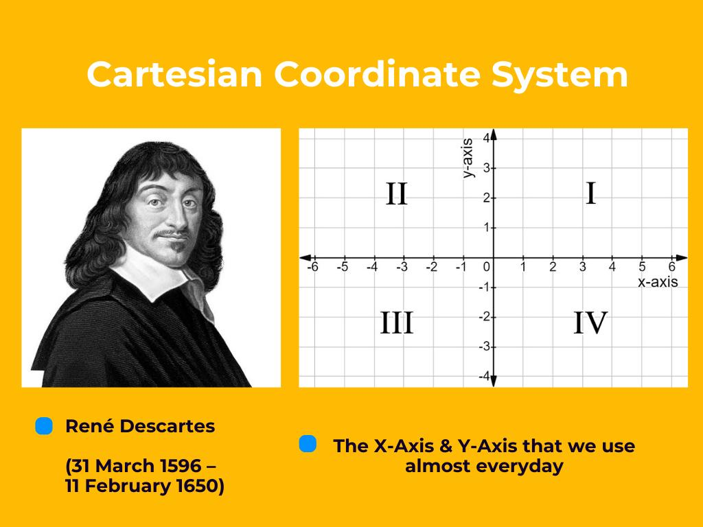
In the 17th century, René Descartes helped establish analytic geometry.
Instead of studying geometric figures only synthetically, geometric relationships could be represented using:
- Coordinates.
- Equations.
- Algebra.
For example, a line can be represented by:
$$y=mx+b$$
A circle can be represented by:
$${\left(x-h\right)}^{2}+{\left(y-k\right)}^{2}=r^{2}$$
This created a powerful connection:
$$\boxed{\text{Geometry}↔\text{Algebra}}$$

20. Coordinate Geometry
# Source: AI Source: Provided by: [Data Path: Persons Table -> ID Column: 1, Name_En Column: Motasem Essam] -> From: [ChatGPT] on [7/25/2026]
The development of the Cartesian coordinate system transformed the study of Euclidean Geometry.
A point could now be represented as:
$$P\left(x , y\right)$$
Distance between two points:
$$\boxed{d=\sqrt{{\left(x_{2}-x_{1}\right)}^{2}+{\left(y_{2}-y_{1}\right)}^{2}}}$$
This allowed many geometric problems to be solved algebraically.
This development eventually led to the field you are organizing as Analytic Geometry.

21. The Parallel Postulate Problem
# Source: AI Source: Provided by: [Data Path: Persons Table -> ID Column: 1, Name_En Column: Motasem Essam] -> From: [ChatGPT] on [7/25/2026]
One of the most important chapters in the history of Euclidean Geometry concerns the Parallel Postulate.
For centuries, mathematicians wondered whether the fifth postulate could be proved using the other four.
Many attempted proofs were proposed.
However, the attempts ultimately helped reveal something much more profound:
$$\boxed{\text{The Parallel Postulate is independent of the other Euclidean postulates}}$$
under modern axiomatic interpretations.

22. Birth of Non-Euclidean Geometry
# Source: AI Source: Provided by: [Data Path: Persons Table -> ID Column: 1, Name_En Column: Motasem Essam] -> From: [ChatGPT] on [7/25/2026]
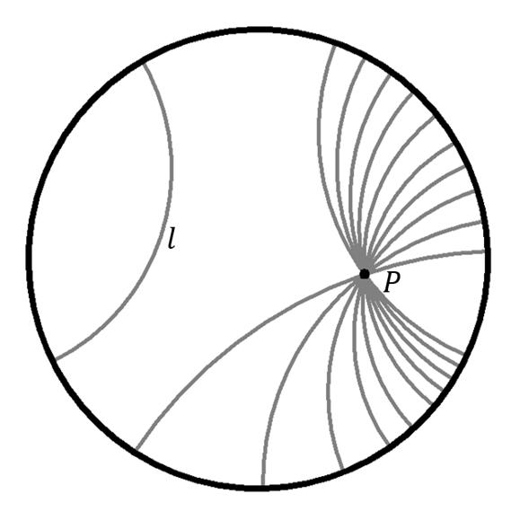
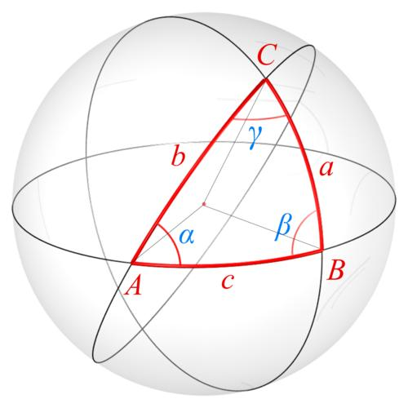
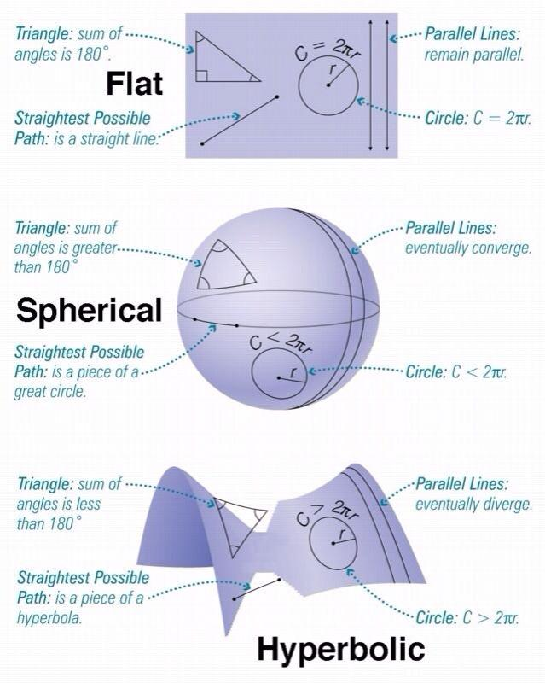
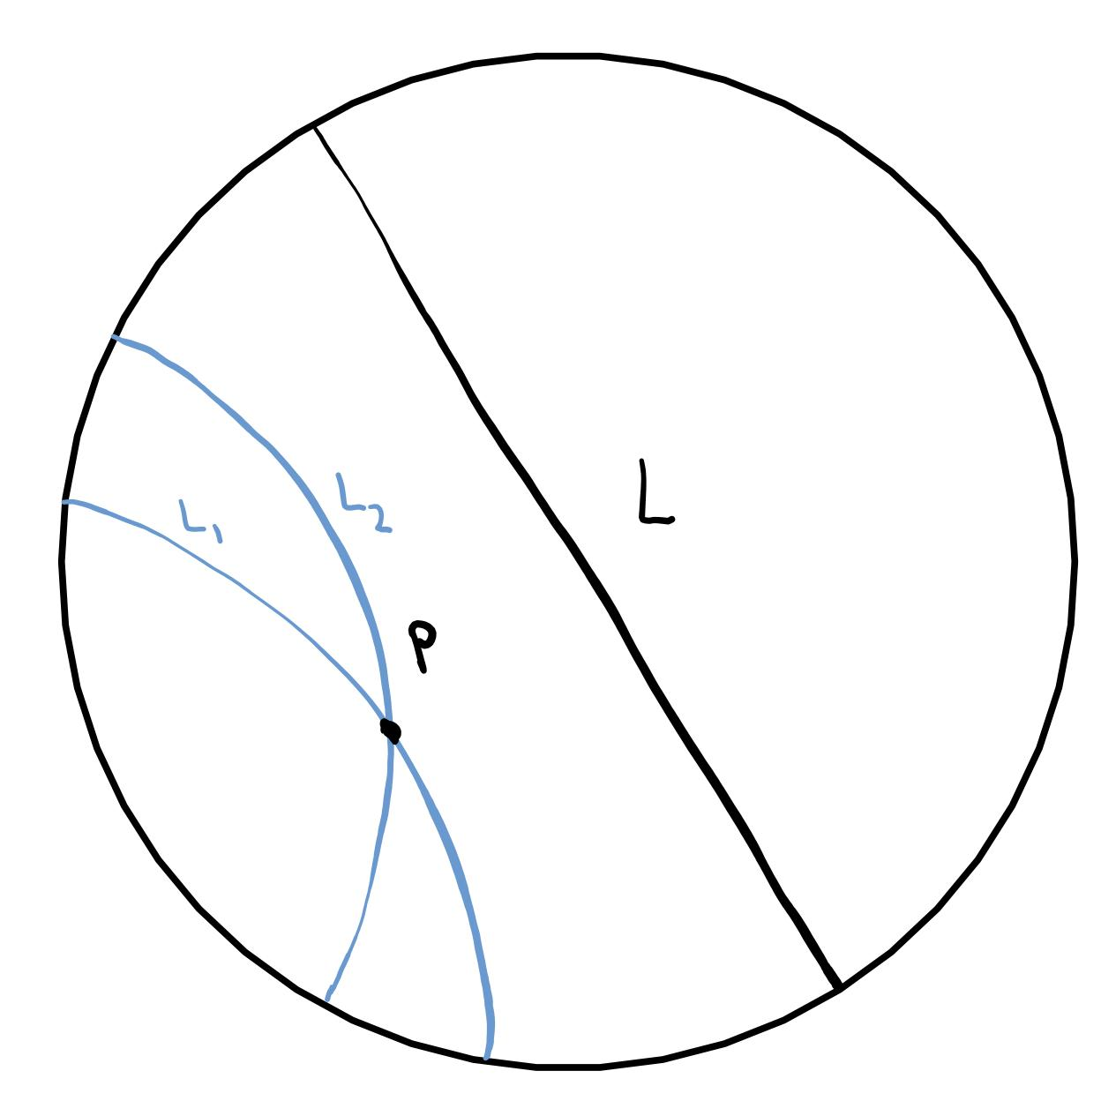
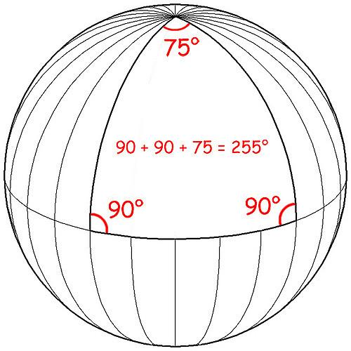
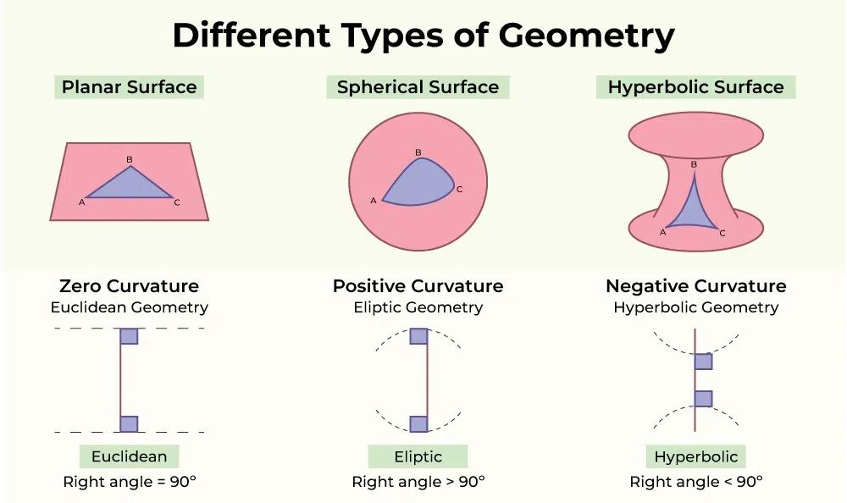
In the 19th century, mathematicians such as:
- Nikolai Lobachevsky
- János Bolyai
- Carl Friedrich Gauss
investigated geometries in which the Parallel Postulate does not hold in the Euclidean form.
This led to Non-Euclidean Geometry.
Two important examples are:
Hyperbolic Geometry
Through a point outside a line, there can be more than one line that does not intersect the original line.
Spherical Geometry
On a sphere, ordinary Euclidean parallel-line behavior does not apply.
This showed that Euclidean Geometry is one possible consistent geometric framework, rather than the only conceivable geometry.

23. Riemann and Curved Geometry
# Source: AI Source: Provided by: [Data Path: Persons Table -> ID Column: 1, Name_En Column: Motasem Essam] -> From: [ChatGPT] on [7/25/2026]
Bernhard Riemann expanded geometric thinking further in the 19th century.
His work helped establish the mathematical study of spaces that can be:
- Curved.
- Higher-dimensional.
- Non-Euclidean.
This development eventually became important in:
- Differential Geometry.
- General Relativity.
- Modern physics.

24. Hilbert and Modern Axiomatic Geometry
# Source: AI Source: Provided by: [Data Path: Persons Table -> ID Column: 1, Name_En Column: Motasem Essam] -> From: [ChatGPT] on [7/25/2026]
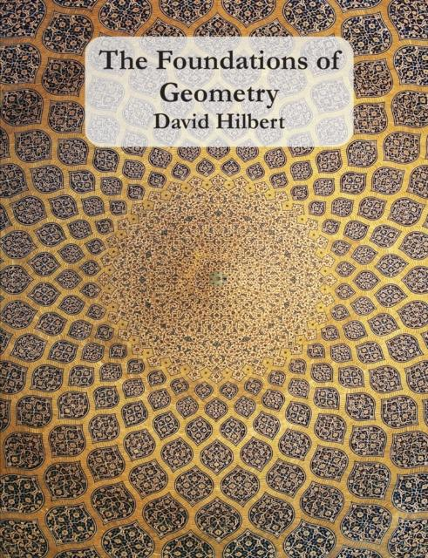
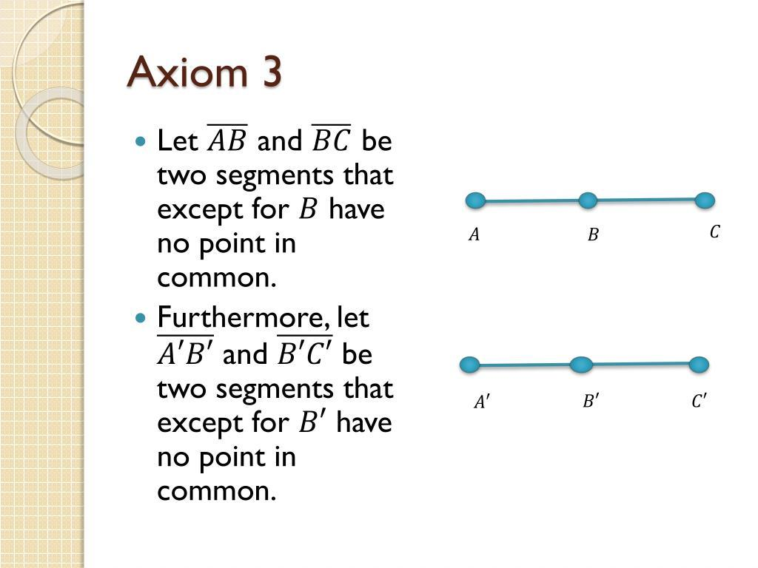
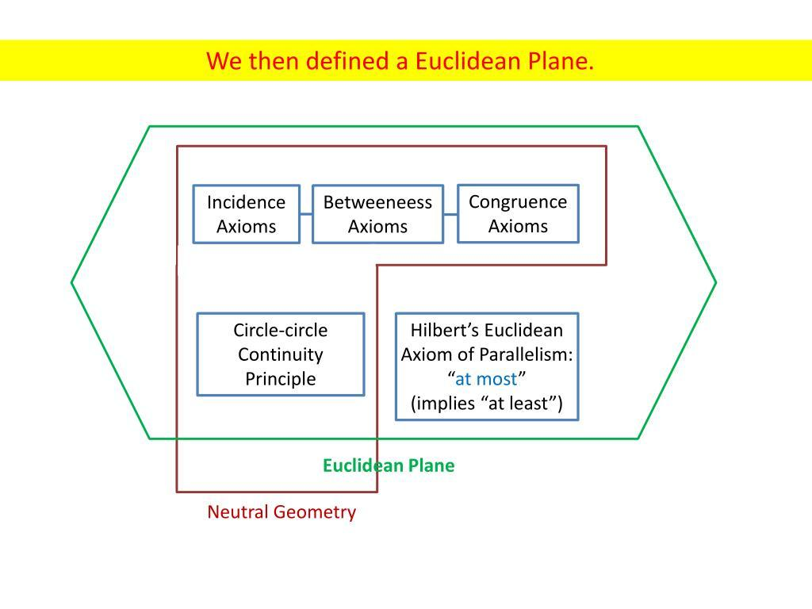
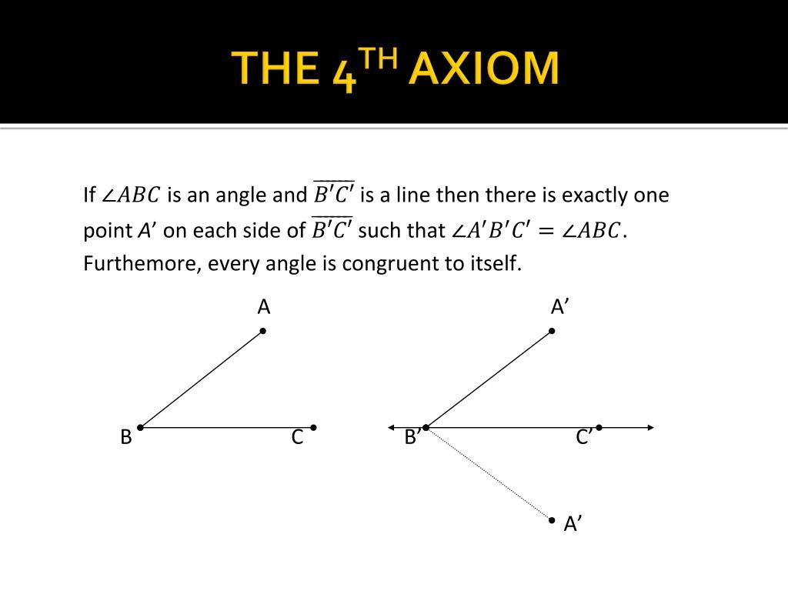
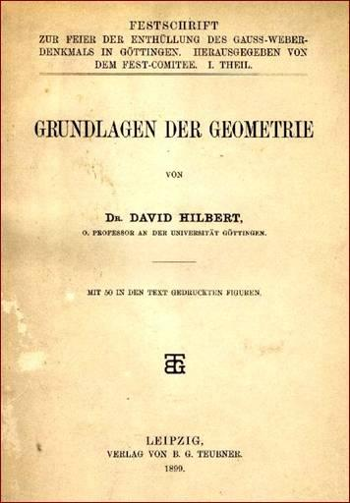
In 1899, David Hilbert published Grundlagen der Geometrie (Foundations of Geometry).
Hilbert reformulated the foundations of geometry using a more rigorous modern axiomatic system.
He emphasized the relationships among fundamental objects such as:
- Points.
- Lines.
- Planes.
and developed groups of axioms concerning:
- Incidence.
- Order.
- Congruence.
- Parallelism.
- Continuity.
This was an important step toward modern mathematical rigor.

25. Euclidean Geometry in the 20th and 21st Centuries
# Source: AI Source: Provided by: [Data Path: Persons Table -> ID Column: 1, Name_En Column: Motasem Essam] -> From: [ChatGPT] on [7/25/2026]
Euclidean Geometry remains fundamental today.
It is studied in:
- School mathematics.
- University mathematics.
- Engineering.
- Architecture.
- Computer graphics.
- Computer-aided design.
- Robotics.
- Computer vision.
- Geographic information systems.
- Physics.
Modern mathematics also studies Euclidean space using more advanced tools such as:
- Linear algebra.
- Coordinate systems.
- Vector geometry.
- Transformations.
- Topology.
- Differential geometry.

Historical Timeline
# Source: AI Source: Provided by: [Data Path: Persons Table -> ID Column: 1, Name_En Column: Motasem Essam] -> From: [ChatGPT] on [7/25/2026]
Period | Development
Ancient Egypt | Practical measurement and geometry
Ancient Mesopotamia | Numerical and geometric calculations
c. 6th century BCE | Greek deductive geometry develops
c. 6th century BCE | Thales and early Greek geometry
c. 6th–5th century BCE | Pythagorean mathematical tradition
4th century BCE | Plato and mathematical philosophy
4th century BCE | Eudoxus and theory of proportions
c. 300 BCE | Euclid and Elements
3rd century BCE | Archimedes develops advanced geometry
3rd century BCE | Apollonius develops conic geometry
Medieval period | Greek geometry preserved and developed in the Islamic world
Renaissance | Euclidean geometry spreads through Europe
17th century | Descartes develops analytic geometry
19th century | Non-Euclidean geometries emerge
Late 19th century | Riemann develops modern geometric ideas
1899 | Hilbert formalizes foundations of geometry
20th–21st centuries | Euclidean geometry integrated with modern mathematics

Major Historical Development
# Source: AI Source: Provided by: [Data Path: Persons Table -> ID Column: 1, Name_En Column: Motasem Essam] -> From: [ChatGPT] on [7/25/2026]
The overall development can be summarized as:
Practical Geometry
(Egypt & Mesopotamia)
↓
Greek Abstract Geometry
↓
Deductive Geometry
↓
Euclid's Elements
↓
Classical Euclidean Geometry
↓
Arabic / Islamic Mathematical Tradition
↓
European Renaissance
↓
Analytic Geometry
↓
Investigation of the Parallel Postulate
↓
Non-Euclidean Geometry
↓
Modern Axiomatic Geometry
↓
Modern Geometry & Mathematical Physics

Major Mathematicians
# Source: AI Source: Provided by: [Data Path: Persons Table -> ID Column: 1, Name_En Column: Motasem Essam] -> From: [ChatGPT] on [7/25/2026]
Mathematician | Major contribution
Thales | Early deductive geometric results
Pythagoras / Pythagorean tradition | Development of mathematical geometry and theorem associated with right triangles
Eudoxus | Proportion and method of exhaustion
Euclid | Systematic axiomatic presentation in Elements
Archimedes | Areas, volumes, circles, exhaustion
Apollonius | Conic sections
Thabit ibn Qurra | Translation and development of Greek mathematics
Ibn al-Haytham | Geometry, optics, mathematical investigations
Descartes | Analytic/coordinate geometry
Gauss | Work related to geometry and curvature; investigation of non-Euclidean ideas
Lobachevsky | Hyperbolic geometry
Bolyai | Hyperbolic geometry
Riemann | Generalized curved geometry
Hilbert | Modern axiomatic foundations of geometry

Relationship with Other Branches of Geometry
# Source: AI Source: Provided by: [Data Path: Persons Table -> ID Column: 1, Name_En Column: Motasem Essam] -> From: [ChatGPT] on [7/25/2026]
Geometry
│
├── Euclidean Geometry
│ ├── Plane Geometry
│ └── Solid Geometry
│
├── Analytic Geometry
│
├── Projective Geometry
│
├── Differential Geometry
│
└── Non-Euclidean Geometry
├── Hyperbolic Geometry
└── Spherical Geometry
Historically, Euclidean Geometry provided one of the major foundations from which many of these later branches developed.

Important Historical Turning Points
# Source: AI Source: Provided by: [Data Path: Persons Table -> ID Column: 1, Name_En Column: Motasem Essam] -> From: [ChatGPT] on [7/25/2026]
1. Practical → Theoretical
Geometry changed from primarily practical measurement to abstract mathematical reasoning.
2. Calculation → Proof
Greek mathematicians increasingly emphasized proving why geometric statements are true.
3. Euclid's Axiomatic System
Elements organized geometric knowledge into a systematic deductive structure.
4. Geometry → Algebra
Descartes connected geometric objects with equations and coordinates.
5. Euclidean → Non-Euclidean
The investigation of the Parallel Postulate revealed that alternative geometries were possible.
6. Classical → Modern Axiomatic Geometry
Hilbert and later mathematicians reformulated the foundations of geometry with greater logical precision.

Real-World Impact
# Source: AI Source: Provided by: [Data Path: Persons Table -> ID Column: 1, Name_En Column: Motasem Essam] -> From: [ChatGPT] on [7/25/2026]
The historical development of Euclidean Geometry influenced:
- Ancient architecture.
- Land surveying.
- Pyramid construction.
- Astronomy.
- Navigation.
- Cartography.
- Renaissance perspective.
- Engineering.
- Architecture.
- Mechanical design.
- Computer graphics.
- Robotics.
- Modern physics.

Key Points
# Source: AI Source: Provided by: [Data Path: Persons Table -> ID Column: 1, Name_En Column: Motasem Essam] -> From: [ChatGPT] on [7/25/2026]
- Geometry existed long before Euclid.
- Ancient Egyptians and Mesopotamians developed practical geometric methods.
- Greek mathematicians transformed geometry into a more abstract and deductive discipline.
- Euclid organized a large body of geometric knowledge in The Elements around 300 BCE.
- Euclid's five postulates became the foundation of classical Euclidean Geometry.
- The Parallel Postulate became one of the most significant problems in the history of mathematics.
- Descartes connected geometry with algebra through coordinate geometry.
- The 19th century development of Non-Euclidean Geometry demonstrated that Euclidean Geometry was not the only possible geometry.
- Riemann expanded geometry to curved and higher-dimensional spaces.
- Hilbert provided a more rigorous modern axiomatic foundation.
- Euclidean Geometry remains fundamental to mathematics, science, engineering, architecture, and computing.

Conclusion
# Source: AI Source: Provided by: [Data Path: Persons Table -> ID Column: 1, Name_En Column: Motasem Essam] -> From: [ChatGPT] on [7/25/2026]
The history of Euclidean Geometry is the history of the transformation of geometry from practical measurement into a rigorous mathematical science.
Ancient Egyptians and Mesopotamians developed practical geometric techniques. Greek mathematicians introduced increasingly abstract reasoning and proof. Euclid then organized much of the known geometric knowledge into the systematic framework of The Elements. For more than two thousand years, this work served as one of the principal models of mathematical reasoning.
Later developments—including coordinate geometry, non-Euclidean geometry, differential geometry, and modern axiomatic systems—expanded the concept of geometry far beyond Euclid's original framework. Nevertheless, Euclidean Geometry remains a fundamental foundation for understanding mathematical space, geometric figures, measurement, and deductive reasoning.

